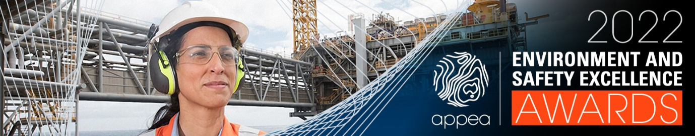
APPEA Company Environment Excellence Award Submission Template
SUBMISSION DETAILS
Organisation Name
Submission Title

CONTACT DETAILS
Person lodging this submission
Job Title
Contact Number
Email

IF YOUR SUBMISSION WAS SUCCESSFUL IN THIS CATEGORY
Who would you like to accept the Award (at the APPEA Conference and Exhibition Dinner)?
Would you like the APPEA secretariat to liaise with your communications team or contact person (listed above)?

DECLARATION
I hereby declare the information enclosed herein and all attachments to be true and complete to the best of my knowledge.
I understand that any information provided in relation to this Award will be used by APPEA and the Assessment Panel for the award judging process.
I authorise the use and public release of all information contained within this submission by APPEA for promotional purposes.
I declare the organisation I am lodging the submission on behalf of does not have any current or ongoing major incident cases open at the time of lodgement. I understand I must notify APPEA of any major incidents occurring during the awards process as this may negate the validity of my submission.

Name:
Signature:
Date:

*Please limit your submission to half a page for each criteria response.

1 CULTURE AND LEADERSHIP
- Positive environmental culture, including demonstrated engagement of senior leaders.
- Demonstrated company-wide focus on environmental performance.
- Support to staff (e.g. training, induction and professional development).
- How the company contributes to APPEA or otherwise provides industry leadership (provide examples).
Add your company information and examples here:

2 PERFORMANCE
- Summary of environmental performance
- Demonstrated prioritisation of environmental outcomes.

Add your company information and examples here

3 RISK MONITORING, EVALUATION AND MANAGEMENT
- Demonstration of a systems-based approach to environmental management.
- Include how existing and emerging environmental risks were identified, monitored, assessed and managed.
Add your company information and examples here

4 ENGAGMENT AND COLLABORATION
- Provide evidence of collaborative and meaningful stakeholder engagement that positively influenced operational control measures.
Add your company information and examples here

5 INNOVATION AND EXTERNAL ADVOCACY
- Demonstrated lower cost solution for more efficient and improved performance.
- Demonstrated innovation –e.g., use of automation, digitisation, and or application of clean technologies.
- Demonstrated use of independent peer reviewed science including commissioned / published literature.
- Commitment to supporting industry wide performance improvement.
- Sharing learnings with relevant stakeholders and industry peers.
Add your company information and examples here

6 OTHER USEFUL SUPPORTING INFORMATION
- Where relevant provide any additional supporting information, graphics, or evidence to support the claims above.
Add your additional information here

